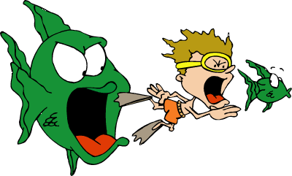
Year 8 Science – Food Chain
Sentences

Writing a good sentence is very important in Science.
It allows us to share information. The sentences we will look at today are simple sentences. Simple sentences contain 1 verb.

A verb is a ___________________ word. Like ____________________________

A noun is a ___________________ word. Like ____________________________

Write a sentence about a food chain that contains a noun, a verb, a noun.

For example: A food chain shows feeding relationships.
noun verb noun
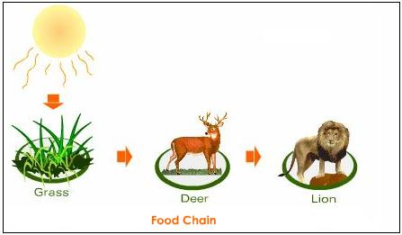

Now write a sentence about a food chain. Maybe something about how it is set out.

__________________________________________________________________

__________________________________________________________________

Now write a sentence about ‘feeding’. Maybe something about what the arrows show and energy flow.

__________________________________________________________________

__________________________________________________________________

Now write a sentence about ‘relationships’. Maybe explain how the position in the food chain gives its relationship to other organisms.

__________________________________________________________________

__________________________________________________________________

Including the first sentence, you should now have four sentences about food chains. You have written four clear statements telling what you know about food chains.
Put all four sentences together below.

__________________________________________________________________

__________________________________________________________________

__________________________________________________________________

__________________________________________________________________

__________________________________________________________________

__________________________________________________________________

__________________________________________________________________

__________________________________________________________________

__________________________________________________________________

You should now have a paragraph about food chains. Well done.



